Bound Morpheme

🔒 What is a Bound Morpheme?
# Source: Chatgpt (GPT-4-turbo) at [7/24/2025]
A bound morpheme is the smallest unit of meaning in a language that cannot stand alone. It must be attached to a free morpheme (or another bound morpheme) to create a meaningful word.

📘 Definition:
# Source: Chatgpt (GPT-4-turbo) at [7/24/2025]
A bound morpheme is a morpheme that cannot function independently and must be affixed to another morpheme (like a root or base word) to convey meaning.

🧾 Examples of Bound Morphemes:
# Source: Chatgpt (GPT-4-turbo) at [7/24/2025]
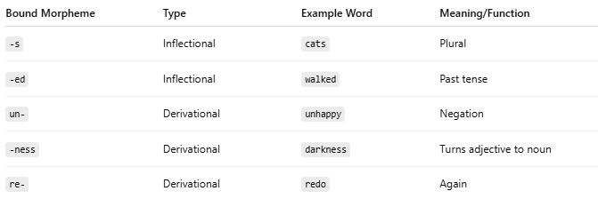
Bound Morpheme | Type | Example Word | Meaning/Function
-s | Inflectional | cats | Plural
-ed | Inflectional | walked | Past tense
un- | Derivational | unhappy | Negation
-ness | Derivational | darkness | Turns adjective to noun
re- | Derivational | redo | Again

🔍 Types of Bound Morphemes:
# Source: Chatgpt (GPT-4-turbo) at [7/24/2025]
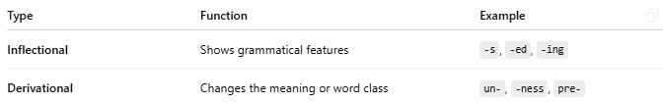

Type | Function | Example
Inflectional | Shows grammatical features | -s, -ed, -ing
Derivational | Changes the meaning or word class | un-, -ness, pre-

🔄 Bound vs. Free Morphemes:
# Source: Chatgpt (GPT-4-turbo) at [7/24/2025]
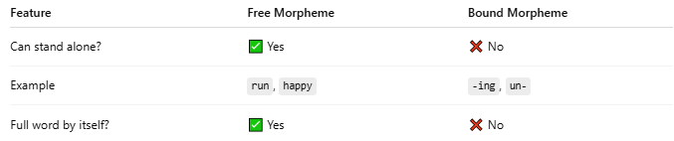
Feature | Free Morpheme | Bound Morpheme
Can stand alone? | ✅ Yes | ❌ No
Example | run, happy | -ing, un-
Full word by itself? | ✅ Yes | ❌ No

🧠 Sentence Example:
# Source: Chatgpt (GPT-4-turbo) at [7/24/2025]
"The runners were running quickly."
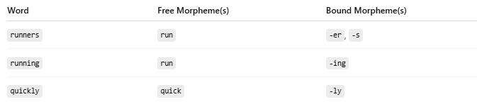
Word | Free Morpheme(s) | Bound Morpheme(s)
runners | run | -er, -s
running | run | -ing
quickly | quick | -ly

✅ Summary:
# Source: Chatgpt (GPT-4-turbo) at [7/24/2025]
A bound morpheme must be attached to something else to have meaning. It cannot stand alone as a word.
They include common prefixes, suffixes, tense markers, plural markers, and more.

